Computer Vision and Integration: Vision Overview

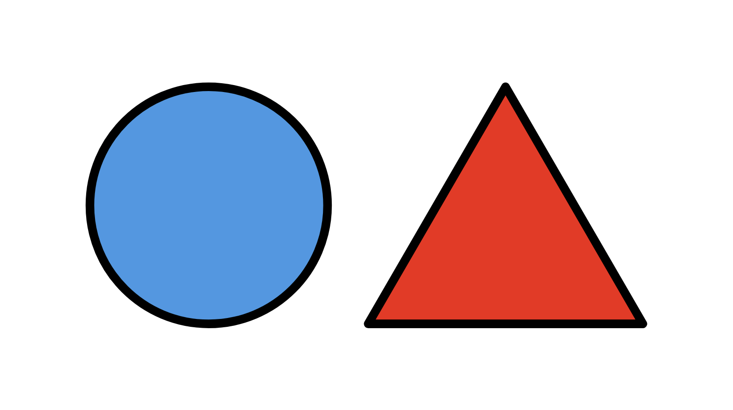

ME500: Advanced Manufacturing
Spring 2026
Variable Product Manufacturing (Thursday PM Lab Group)
Chris Daub, Riley Hubscher, Mukhamed Kerimkul, Bramasto Prasojo, and Chaitanya Sai Nikith Rambha

Table of Contents
Overview 2
Process Diagram 3
Setup 4
Codebase 4
Integration Scripts 4
listener_server.py 4
modbus_server.py 5
Vision.py 6
Overview 6
Camera 6
Crop 7
Process 8
Identify 8
vision_test.py 8
Misc. Scripts 9
vision_utils.py 9
vision_extras.py 9
Supporting Elements 10
Camera Mount 10
Tray Pegs 10
Conclusion 11

Overview
This document contains a high level flow chart for the vision system functionality and a description for each of the files highlighting key operations. All python files can be found in the attached zip folder.
The general function of the system is to scan the lid of the swivel hook product to determine if the lid is of the tall or short type. This process is started by Rosie and later communicated back to Rosie. Upon completion, Rosie is able to correctly identify which assembly procedure to perform.
This project relies heavily on OpenCV, the “world’s largest computer vision library” as per their website. More information can be found here: OpenCV - Open Computer Vision Library

Process Diagram
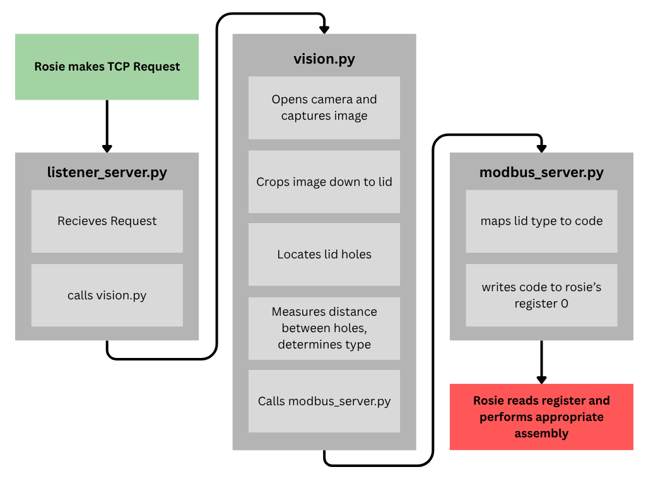
Fig. 1 - General Code Flowchart
The flow diagram above shows the key functionality from call to post of the vision system. An important note: both listener_server.py and modbus_server.py must be started in individual terminals before running BUMES. Test and utility files are not shown.

Setup
The vision system is run on the computer at station 1 and requires python 3.14.3. Setting up a virtual environment in VS Code is crucial to not breaking the existing code for the ink making lab and system. The following code must be run in order to retrieve all dependencies.
>> pip install -r requirements.txt
From here, the following code must be run in separate terminals to start up the vision system.
>> python listener_server.py
>> python modbus_server.py
At this point, you should have a working computer vision block for the FMC. The rest of this document will cover functionality of the code base.

Codebase

Integration Scripts
All text in bold is a function, all text in bold italics is a script

listener_server.py
listener_server.py is responsible for handling incoming requests from Rosie. The print statements in listener_server.py verify the server started successfully and that communications are properly carried out.
The following variables designate host and port for the server and must match Rosie’s settings.
HOST = "10.241.34.37"
PORT = 30002
listener_server_test.py runs a local server and verifies connections can be handled. This test can be run with the following command.
>> python listener_server_test.py

modbus_server.py
modbus_server.py acts like a “message board”, allowing the vision system to post to Rosie, setting a registry such that Rosie has access to the results of vision.py. Almost all of the code is setup for the server.
The following variables designate host, client, and port for modbus server.
HOST = '0.0.0.0'
CLIENT = "127.0.0.1"
PORT = 502
REGISTER_ADDRESS = 0
There is a short snippet of code at the bottom that can be uncommented as a test.
>> python listener_server_test.py

Vision.py

Overview
vision.py is responsible for connecting to the camera, the capture of an image, and the computer vision algorithm that determines the lid type. The computer vision algorithm consists of 3 major steps: crop, process, and identify. The algorithm is encapsulated in lidTypeIndicator

Camera
The camera is handled by the scan function. scan connects to the camera, buffers 30 frames and captures an image. This is attempted 3 times to ensure a success.
The following argument defines which camera input to use and may need adjustment.
cv2.VideoCapture(cv2.CAP_DSHOW)
During early development, scan was forced to return a preloaded image for local testing.
scan captured the following image which will be used for the rest of the documentation.
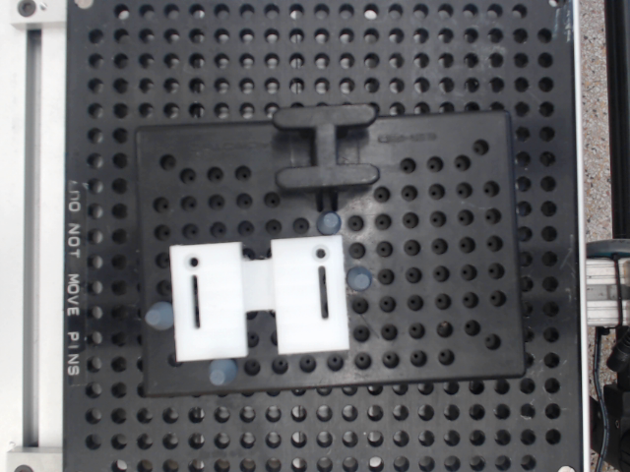
Fig. 2 - Test Image

Crop
The crop step begins by calling clipBlacks which sets all pixels less than 200 (nearly white) to black
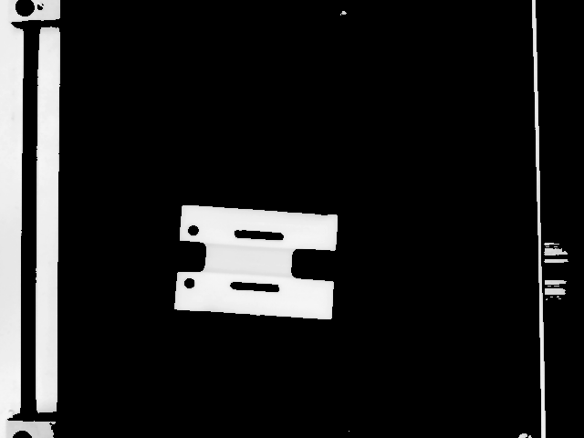
Fig. 3 - clipBlacks() Result
The resulting image is then passed to findLargestConnected This function finds all contiguous white areas and returns a “stats” object. crop is then passed the clipped image and the stats and crops the image down to the lid.
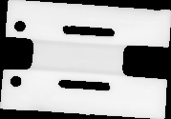 | 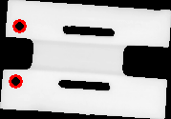
Fig. 4 - crop Result | Fig. 5 - findHoles Result

Process
The process step is handled by findHoles. This applies an open CV blob detector to find the locations of holes based on various parameters like circularity, area, etc. These were fine tuned for the lid’s holes, primarily to filter out larger and smaller holes. Documentation can be found here: https://docs.opencv.org/4.x/d0/d7a/classcv_1_1SimpleBlobDetector.html. See Fig. 6 for results. All found holes are then passed to calcHoleSpacing which measures the distance between all pairs of holes. In our case that is only 2. Previous lid types required this more sophisticated approach.

Identify
The resulting hole distance is passed to lidTypeByHoles. This function takes the shortest distance between each of the hole pairs and compares them to a threshold value, in our case 85. This number was arrived at after running calcHoleSpacing on over 600 images, taking the average for both lid types and finding the midpoint, 85, which acts as a threshold. For the short lids, distances were ~110 and for the tall lids, distances were ~60, with each having a variance of ~.15. This produces a confidence interval of ±0.044 for each lid type. The threshold of 85 sits nearly 11 standard deviations away from either distribution's mean. By common quality standards, the algorithm is always right.

vision_test.py
vision_test.py was absolutely critical in producing a reliable algorithm. Functionality is for setting up tests and running them. Tests are run on vision.lidTypeIndicator, providing a holistic test of the vision algorithm. Key functionality includes
- bulkImagePath which creates a path for saving and retrieving images,
- testMessageHandler which provides consistent test messaging,
- individualTest which allows testing of individual images
- bulkTest which runs bulk testing
- bulkSave which captures a given number of images from the camera.
bulkSave was run 4 times during different times of the day, each capturing 200 images of each lid.

Misc. Scripts

vision_utils.py
This file holds utilities used across various parts of the system. One particularly useful addition RESULT_CODES allows the entire system to have one source of truth as well as quick changes if necessary, and even additions for any future expansions.
RESULT_CODES = ["unknown","tall","short",]
Other utilities include crop, saveImage, and loadImage.
Two functions displayWindow and drawStuffShowStuff are absolutely crucial in debugging, allowing the user to see the image during any step of processing.

vision_extras.py
This file acts as a collection of open CV functions not used. These provide a good jumping off point for anyone interested in expanding the functionality of this project or their own.

Supporting Elements

Camera Mount
A web cam mount was created using 8020 on the existing camera frame at station 1. This mount is adjustable vertically and proved to be reliable across 2 teams projects.
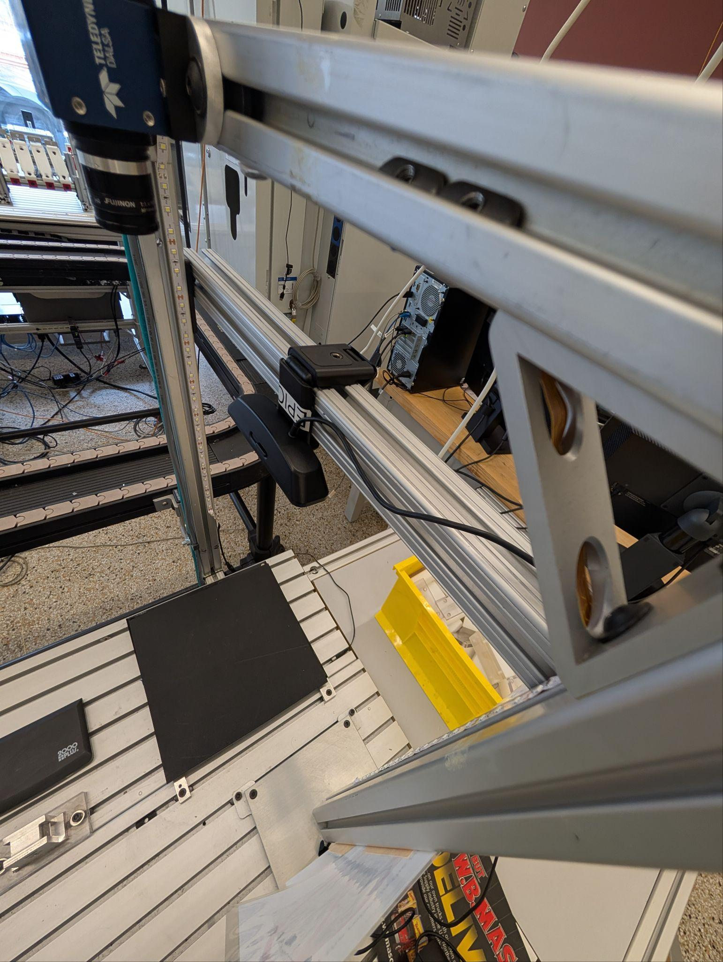 | 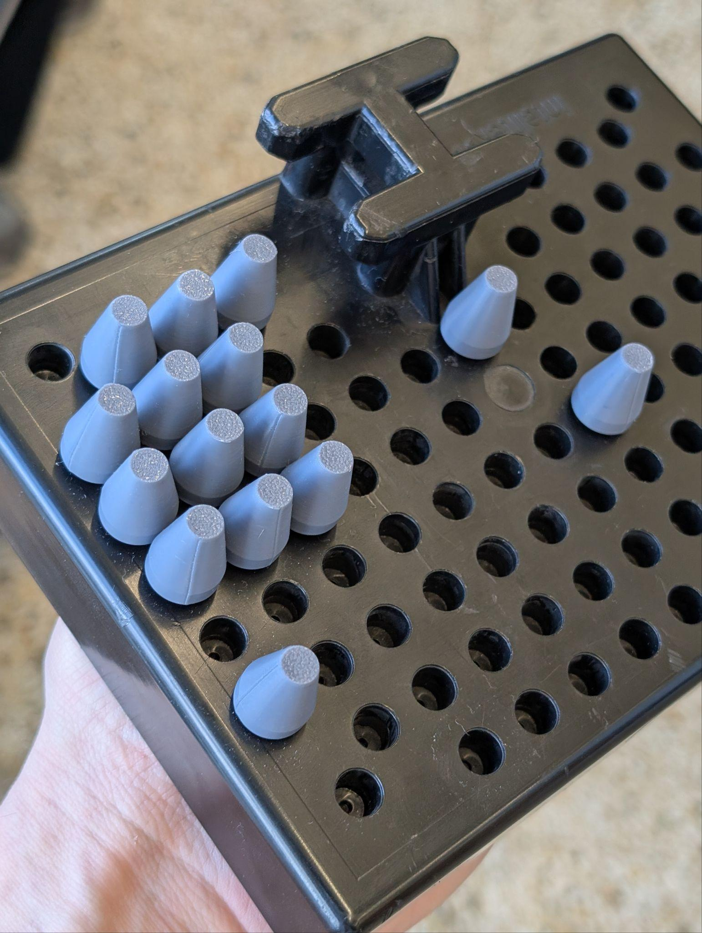
Fig. 5 - Camera Mount | Fig. 6 - Tray Pegs

Tray Pegs
The existing metal tray pegs produced white pixels in the captured image adding unnecessary complexity. The pegs were modeled in CAD and 3d printed, acting just as well while simplifying the computer vision algorithm.

Conclusion
At the conclusion of this project, the system demonstrated strong stability and accuracy throughout testing. Both servers operated without failure, and the computer vision algorithm consistently produced correct results. While the algorithm itself is relatively straightforward, its reliability highlights how thoughtful design decisions can significantly improve both system performance and overall quality.
Initially, the plan included developing and benchmarking multiple algorithms — testing each independently and exploring whether ensemble approaches might yield better accuracy. Due to time constraints, this was not pursued, though it remains a worthwhile direction for future work. I had also hoped to implement conditional behaviour off the unknown category, providing a toy example of quality control.
The system as delivered provides a robust and well-structured foundation for further development. The core components — listener_server.py, modbus_server.py, vision_utils.py and vision_test.py — are each designed to work with this implementation of vision.py but there wete built with extensibility in mind, accelerating any future implementations of vision.py. Potential directions include implementing more complex conditional logic, create a quality control system, or adapting the entry point to drive conditional behaviour earlier in the ADML.

